How to Book PSYO Shared Labs at <http://bookings.ok.ubc.ca/psyolab>

***NOTE: Only Psychology department faculty, staff and students may book these shared labs. Non-PSYO bookings will be deleted.***

ART 280J (1 desk, 1 MAC and 1 laptop, 2 chairs)

ART 351A (3 desks, chairs, laptops)

ART 351B (2 desks, chairs, laptops)

ART 351C (3 desks, chairs but # of laptops TBD)

ART 353A Scantron Room/Poster Printer

1. Log In to <http://bookings.ok.ubc.ca/psyolab> using your CWL and password.

If you do not have a CWL and password, please ask your faculty member to reserve the lab for you and send these instructions along with the day(s), times and lab room number.

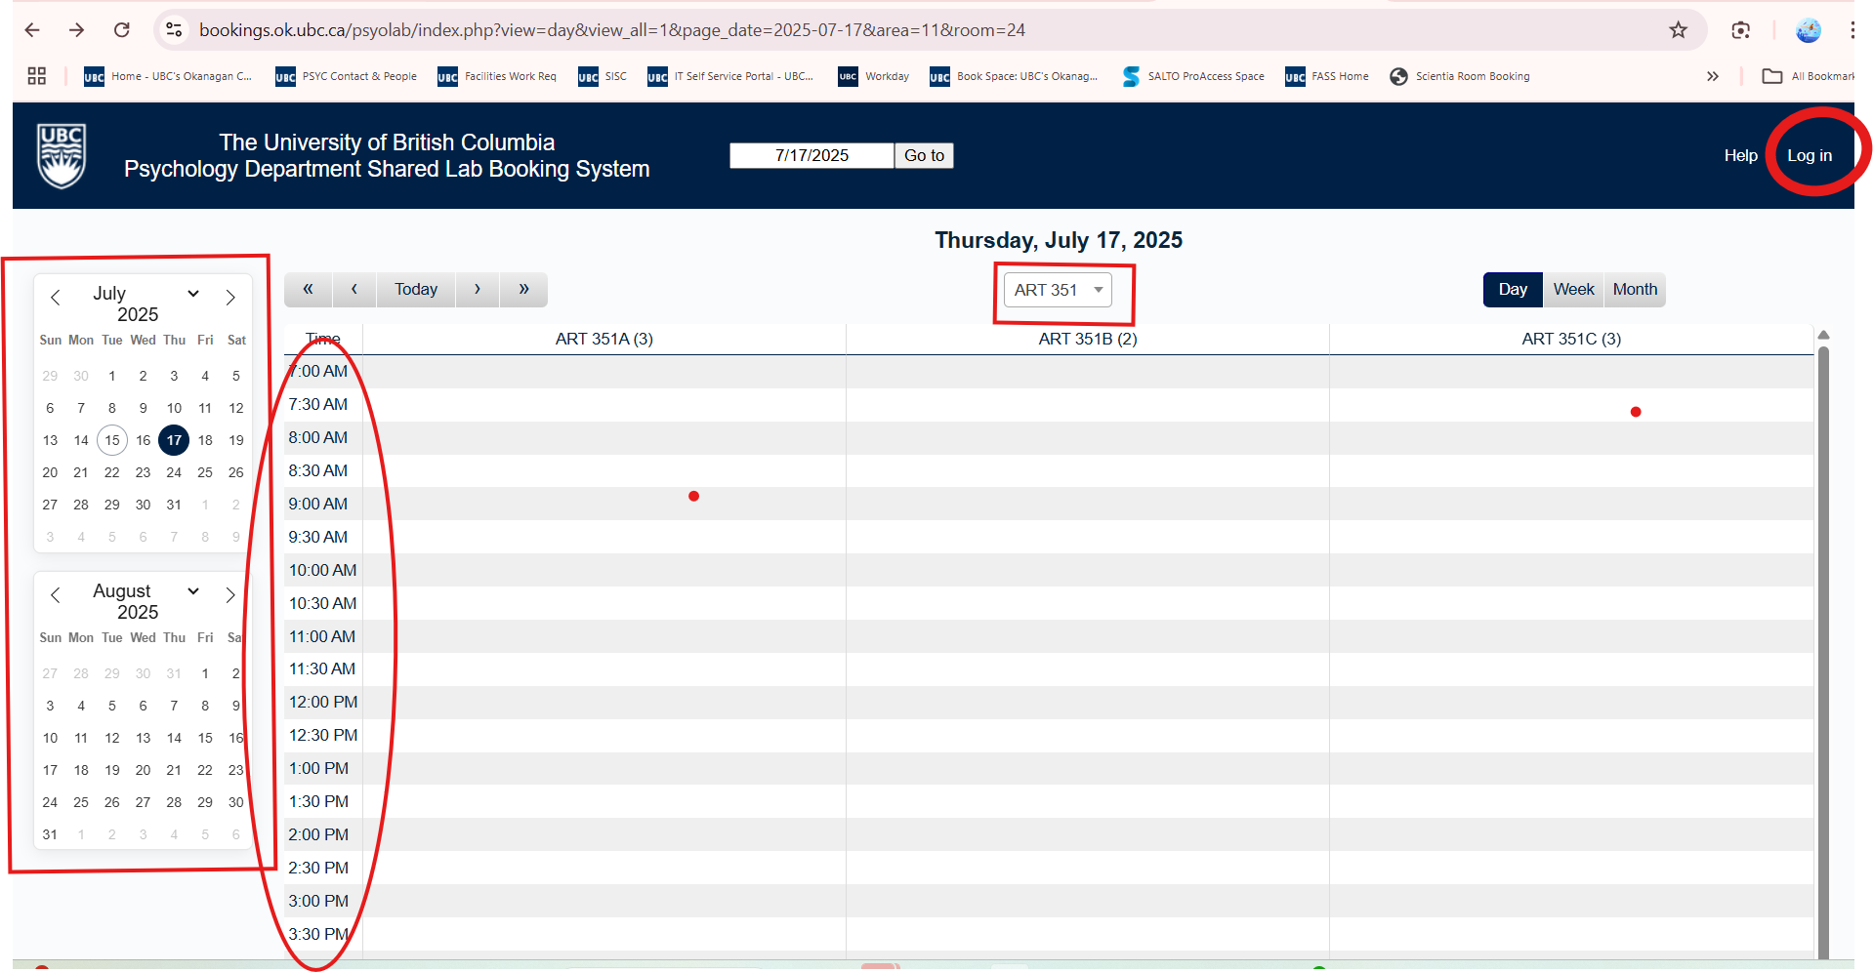

1. Select the first date in calendars on left.
2. Select the room top middle of page (e.g. for ART 351B, select ART 351 and you’ll see ART 351B).
3. Click the box next to the first start time (e.g. 9am). Complete the fields highlighted below. Be very descriptive in your Descriptions, Brief & Full.

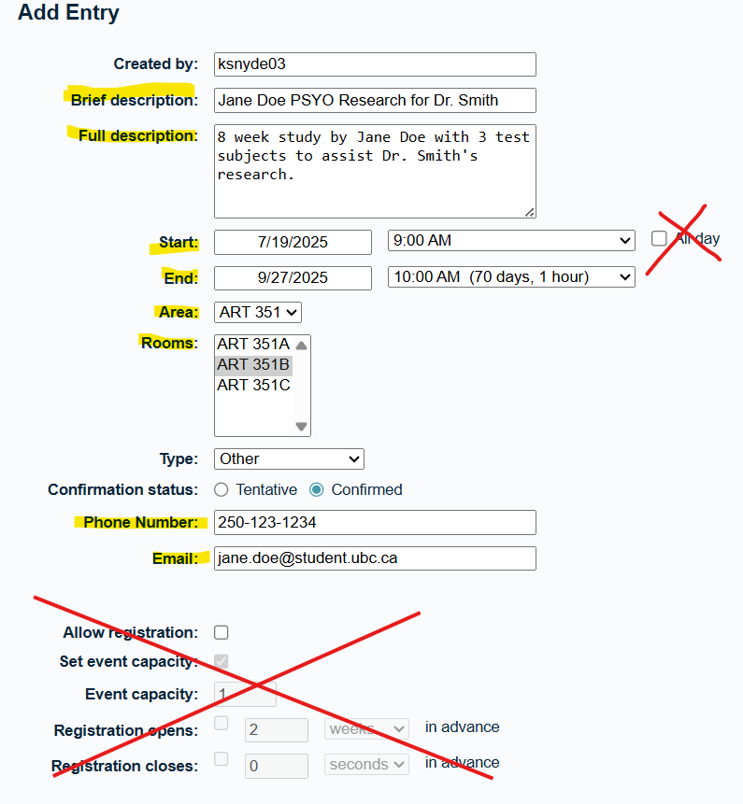

NOTE: there is a 4 hour daily limit per booking to allow space for others. If you need > 4 hours/day, please email [psychology.okanagan@ubc.ca](mailto:psychology.okanagan@ubc.ca) with your faculty member cc’d on the email.

NOTE: If you are setting a recurring booking (e.g. same day & time every week for 8 weeks), then do NOT select an End Date as it will auto-populate when you set up Repeat Type (see next step).

1. For recurring bookings, make your choices in Repeat Type area:

NOTE: Do NOT select “Skip past conflicts”.

1. You are finished booking a shared lab. Please log off. NOTE: As stated earlier, if you are not a Psychology student or instructor, your booking will be deleted.

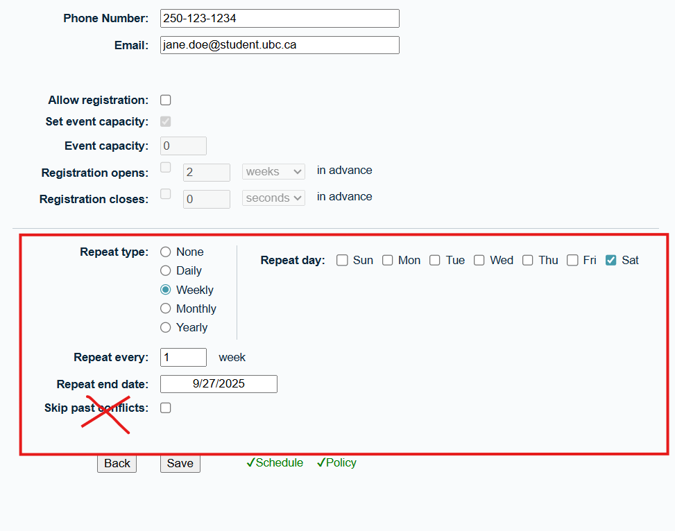

1. Save.
2. If you need to make a change, Log in or click UBC logo at top left.
3. Select Room and go to booking date you want to change.
4. Select booking.

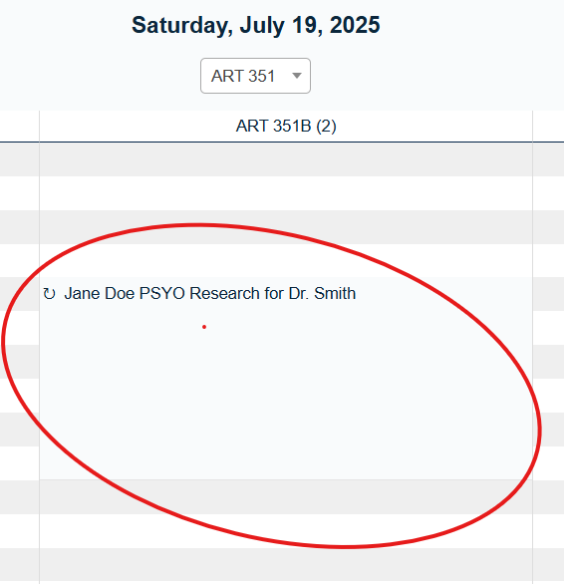

1. Select menu item for change (e.g. Edit Entry, Edit Series, etc.).

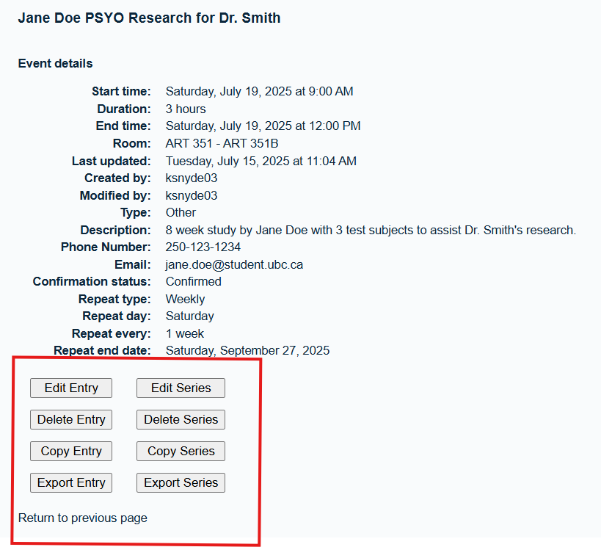

Your lab booking is now complete. You will receive a confirmation email.

In respect of others, **PLEASE delete any bookings** you have decided to cancel. These are shared labs and their success depends on your cooperation.

Thank you,

Psychology Administrative Staff